## Name: Laura C. Larregui Date: February 19, 2020

## Lab 07 – Advanced Query

### Part 1 – Exploratory Data Analysis

1. First Exploratory Analysis

SELECT

vc_User.UserName

, vc_User.EmailAddress

, vc_VidCast.vc_VidCastID

FROM vc_VidCast

JOIN vc_User ON vc_User.vc_UserID = vc_VidCast.vc_UserID

ORDER BY vc_User.UserName

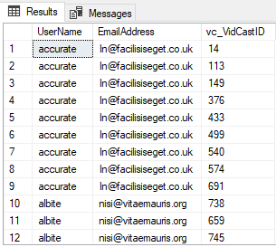

1. Basic Summaries (Looking at the users without VidCasts

SELECT * FROM vc_User

WHERE vc_UserID NOT IN (SELECT vc_UserID FROM vc_VidCast)

--INCLUDES ALL USERS

SELECT

vc_User.UserName

, vc_User.EmailAddress

, vc_VidCast.vc_VidCastID

FROM vc_VidCast

RIGHT JOIN vc_User ON vc_User.vc_UserID = vc_VidCast.vc_UserID

ORDER BY vc_User.UserName

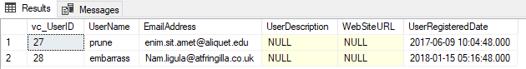

1. RIGHT JOIN

SELECT

vc_User.UserName

, vc_User.EmailAddress

, vc_VidCast.vc_VidCastID

FROM vc_VidCast

RIGHT JOIN vc_User ON vc_User.vc_UserID = vc_VidCast.vc_UserID

ORDER BY vc_User.UserName

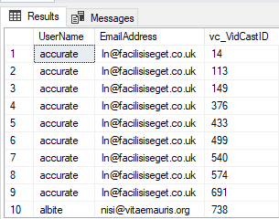

1. AGGREGATE FUNCTIONS

SELECT

COUNT(vc_VidCastID) as NumberOfVidCasts

, SUM(ScheduleDurationMinutes) as TotalScheduledMinutes

, MIN(ScheduleDurationMinutes) as MinScheduledMinutes

, AVG(ScheduleDurationMinutes) as AvgScheduledMinutes

, MAX(ScheduleDurationMinutes) as MaxScheduledMinutes

FROM vc_VidCast



1. GROUP BY

SELECT

vc_User.UserName

, vc_User.EmailAddress

, COUNT(vc_VidCast.vc_VidCastID) AS CountOfVidCasts

FROM vc_VidCast

RIGHT JOIN vc_User ON vc_User.vc_UserID = vc_VidCast.vc_UserID

GROUP BY vc_User.UserName, vc_User.EmailAddress

ORDER BY CountOfVidCasts DESC, vc_User.UserName

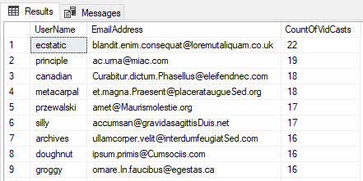

1. HAVING

SELECT

vc_User.UserName

, vc_User.EmailAddress

, COUNT(vc_VidCast.vc_VidCastID) AS CountOfVidCasts

FROM vc_VidCast

RIGHT JOIN vc_User ON vc_User.vc_UserID = vc_VidCast.vc_UserID

GROUP BY vc_User.UserName, vc_User.EmailAddress

HAVING COUNT(vc_VidCast.vc_VidCastID) <10

ORDER BY CountOfVidCasts DESC, vc_User.UserName

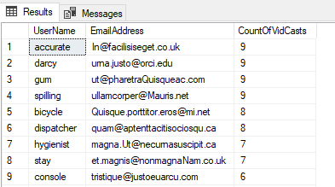

1. Exploratory Data Analysis

SELECT

vc_User.UserName

, vc_User.EmailAddress

, SUM(DATEDIFF(n, StartDateTime, EndDateTime)) AS SumActualDurationMinutes

FROM vc_VidCast

JOIN vc_User ON vc_User.vc_UserID = vc_VidCast.vc_UserID

JOIN vc_Status ON vc_Status.vc_StatusID = vc_VidCast.vc_StatusID

WHERE vc_Status.StatusText='Finished'

GROUP BY vc_User.UserName, vc_User.EmailAddress

ORDER BY vc_User.UserName

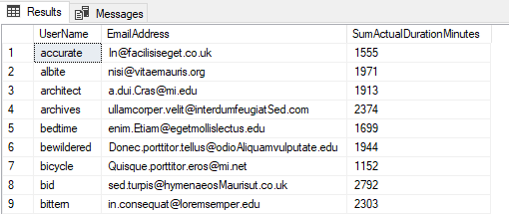

### Part 2 – Putting All Together

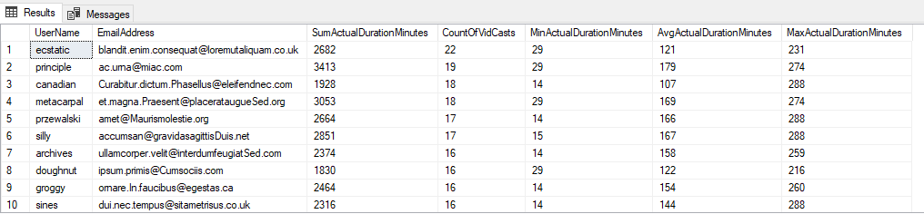

### Query File

/*

Name: Laura Larregui

Date: 2/19/2020

Lab 07: Advanced Query

*/

--Exploratory Data Analysis

SELECT

vc_User.UserName

, vc_User.EmailAddress

, vc_VidCast.vc_VidCastID

FROM vc_VidCast

JOIN vc_User ON vc_User.vc_UserID = vc_VidCast.vc_UserID

ORDER BY vc_User.UserName

-- BASIC SUMMARIES

-- LOOK FOR USER THAT DON'T HAVE VIDEOS

SELECT * FROM vc_User

WHERE vc_UserID NOT IN (SELECT vc_UserID FROM vc_VidCast)

--INCLUDES ALL USERS

SELECT

vc_User.UserName

, vc_User.EmailAddress

, vc_VidCast.vc_VidCastID

FROM vc_VidCast

RIGHT JOIN vc_User ON vc_User.vc_UserID = vc_VidCast.vc_UserID

ORDER BY vc_User.UserName

-- HIGH-LEVEL DESCRIPTIVE STATS

SELECT

COUNT(vc_VidCastID) as NumberOfVidCasts

, SUM(ScheduleDurationMinutes) as TotalScheduledMinutes

, MIN(ScheduleDurationMinutes) as MinScheduledMinutes

, AVG(ScheduleDurationMinutes) as AvgScheduledMinutes

, MAX(ScheduleDurationMinutes) as MaxScheduledMinutes

FROM vc_VidCast

--GROUP BY CLAUSE

SELECT

vc_User.UserName

, vc_User.EmailAddress

, COUNT(vc_VidCast.vc_VidCastID) AS CountOfVidCasts

FROM vc_VidCast

RIGHT JOIN vc_User ON vc_User.vc_UserID = vc_VidCast.vc_UserID

GROUP BY vc_User.UserName, vc_User.EmailAddress

ORDER BY CountOfVidCasts DESC, vc_User.UserName

--HAVING CLAUSE

SELECT

vc_User.UserName

, vc_User.EmailAddress

, COUNT(vc_VidCast.vc_VidCastID) AS CountOfVidCasts

FROM vc_VidCast

RIGHT JOIN vc_User ON vc_User.vc_UserID = vc_VidCast.vc_UserID

GROUP BY vc_User.UserName, vc_User.EmailAddress

HAVING COUNT(vc_VidCast.vc_VidCastID) <10

ORDER BY CountOfVidCasts DESC, vc_User.UserName

-- more EDA

SELECT

vc_User.UserName

, vc_User.EmailAddress

, SUM(DATEDIFF(n, StartDateTime, EndDateTime)) AS SumActualDurationMinutes

FROM vc_VidCast

JOIN vc_User ON vc_User.vc_UserID = vc_VidCast.vc_UserID

JOIN vc_Status ON vc_Status.vc_StatusID = vc_VidCast.vc_StatusID

WHERE vc_Status.StatusText='Finished'

GROUP BY vc_User.UserName, vc_User.EmailAddress

ORDER BY vc_User.UserName

-- Part 2: Putting All together

SELECT

vc_User.UserName

, vc_User.EmailAddress

, SUM(DATEDIFF(n, StartDateTime, EndDateTime)) as SumActualDurationMinutes

, COUNT(vc_VidCast.vc_VidCastID) AS CountOfVidCasts

, MIN(DATEDIFF(n, StartDateTime, EndDateTime)) as MinActualDurationMinutes

, AVG(DATEDIFF(n, StartDateTime, EndDateTime)) as AvgActualDurationMinutes

, MAX(DATEDIFF(n, StartDateTime, EndDateTime)) as MaxActualDurationMinutes

FROM vc_VidCast

RIGHT JOIN vc_User ON vc_User.vc_UserID = vc_VidCast.vc_UserID

GROUP BY vc_User.UserName, vc_User.EmailAddress

ORDER BY CountOfVidCasts DESC, vc_User.UserName